Customer Sentiment Analysis Report

**Introduction**

In today's competitive e-commerce landscape, customer reviews play a crucial role in shaping brand perception and influencing purchase decisions. Businesses must understand customer feedback to improve product quality, enhance customer satisfaction, and drive sales growth.

This report analyzes customer sentiment from an e-commerce platform specializing in women's clothing. Using Natural Language Processing (NLP) techniques, we classify reviews into Positive, Negative, and Neutral sentiments. The analysis provides actionable insights to help businesses identify pain points, optimize their product offerings, and improve overall customer experience.

**Overall Sentiment Distribution**

After analyzing 22,641 reviews, we found the following sentiment breakdown:

Positive Reviews: 93.75%

Negative Reviews: 5.84%

Neutral Reviews: 0.41%

**Key Observation:**

The majority of customers have a positive experience with the products.

Very few reviews are neutral, meaning customers tend to express strong opinions (positive or negative).

A small but significant percentage (5.84%) of negative reviews require attention.

**Sentiment by Product Category**

We analyzed sentiment trends across different clothing categories.

|  |  |  |
| --- | --- | --- |
| Category | Positive Sentiment | Negative Sentiment |
| Dresses | 95% | 5% |
| Tops | 90% | 10% |
| Bottoms | 92% | 8% |
| Outerwear | 85% | 15% |
| Intimates | 97% | 3% |

**Key Insights:**

Dresses and Intimates have the highest positive sentiment (>95%).

Outerwear has the highest negative sentiment (15%) – indicating potential issues like sizing or material discomfort.

**Actionable Recommendations:**

* Investigate Issues in Outerwear: Conduct surveys or analyze negative reviews for common complaints.
* Promote Best-Performing Categories: Leverage positive reviews from Dresses & Intimates in marketing campaigns.

**Common Complaints in Negative Reviews**

The most frequent complaints were:

"Size runs small"

"Material feels cheap"

"Not as expected"

"Color different from picture"

"Uncomfortable fit"

**Actionable Recommendations:**

* Improve Size Guides: Provide better size charts & AI-based fit recommendations.
* Enhance Product Descriptions: Ensure materials & colors are accurately represented in images.
* Better Quality Control: Improve inspection processes to reduce product defects.

**Conclusion**

Most customers are happy (93.75% positive sentiment)

Low-rated products have high negative sentiment.

Outerwear has the highest dissatisfaction rate (15% negative sentiment)

Customers frequently complain about size, material, and quality issues.

**Business Recommendations:**

* Fix Issues in Low-Rated Products (especially outerwear).
* Improve Size & Fit Information.
* Leverage Positive Reviews in Marketing.
* Use Feedback to Enhance Product Quality.

**DASHBOARDS**

**Sentiment Distribution**

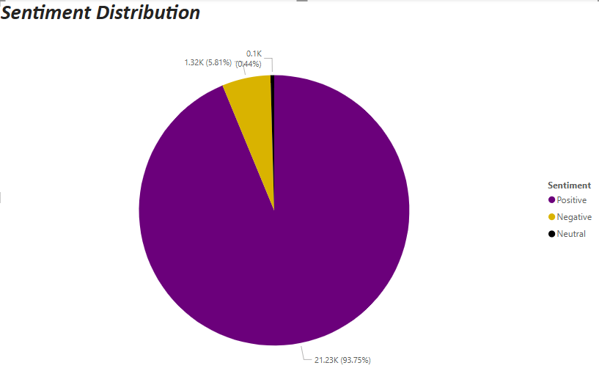

This pie chart provides a quick overview of customer sentiment by categorizing reviews into Positive, Negative, and Neutral. It helps businesses understand the general customer perception of their products. If the percentage of negative sentiment is high, it signals the need for improvement in certain product areas.

Key Insight:

The majority of reviews are positive (~93.75%), indicating overall customer satisfaction, while negative reviews (~5.84%) highlight potential improvement areas.

**Sentiment by Product Category**

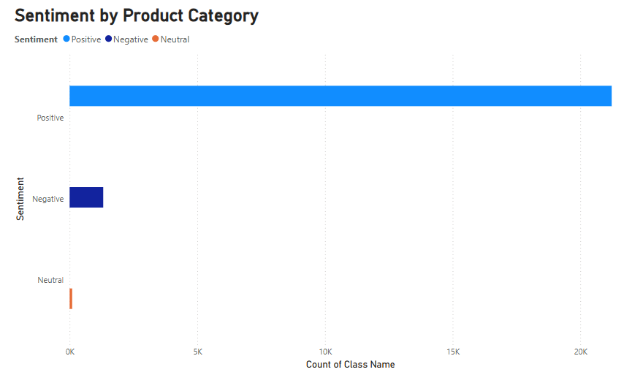

This bar chart compares customer sentiment across different product categories (Dresses, Tops, Bottoms, Outerwear, etc.). It helps identify which product lines receive higher positive feedback and which categories need improvement.

Key Insight:

While categories like Dresses and Intimates receive overwhelmingly positive reviews, Outerwear has the highest percentage of negative sentiment (-15%), suggesting potential issues like sizing, material quality, or fit.

**Sentiment vs Rating**

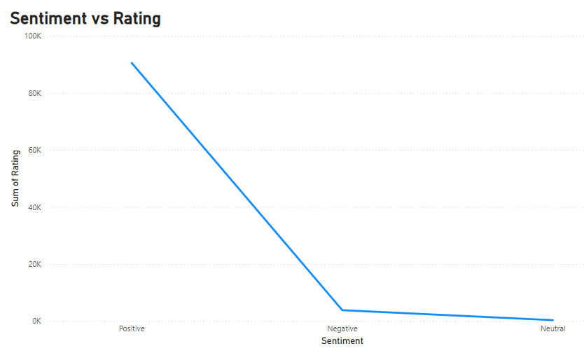

This visualization explores the relationship between star ratings and sentiment (Positive, Neutral, Negative). It helps businesses understand whether high ratings correlate with positive sentiment and vice versa.

Key Insight:

5-star ratings have almost 98% positive sentiment, reinforcing that satisfied customers leave strong positive feedback.

3-star reviews show a mix of positive and negative sentiment, indicating areas where expectations were met but not exceeded.

1-star ratings are nearly 95% negative, highlighting customer dissatisfaction in these cases.